**Three circles inside an equilateral triangle**

Three circles, may or may not have the same radii, are placed inside an equilateral triangle with each side of length 2a. The circles can touch the sides of the triangle. Find the maximum of the sum of the area of these three circles.

**Scenario 1**

Let 3 identical circles of radii r inscribed in the equilateral triangle as in the following diagram:

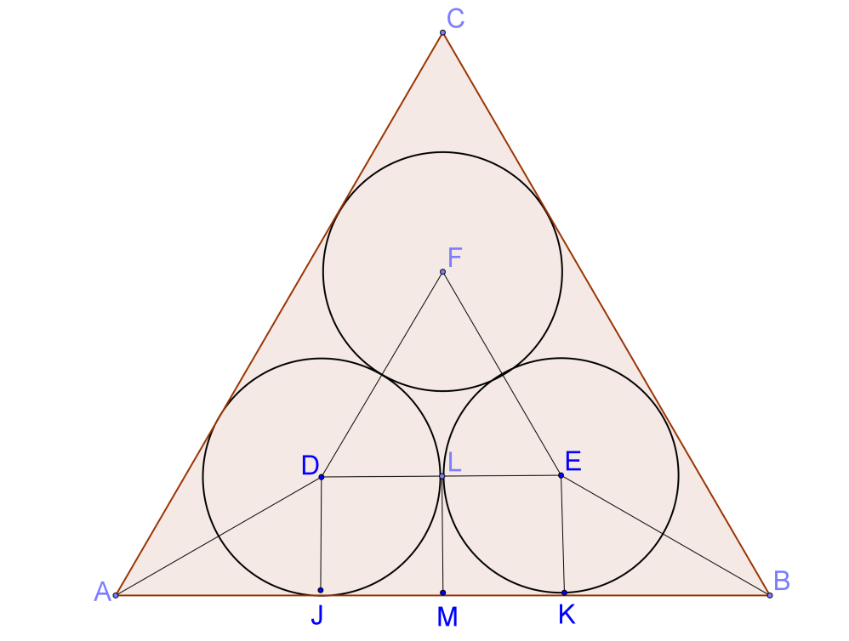

Since $∆AJD, ∆BKF$ are $30°-60°-90°$ triangles, we have:

$$AB=AJ+JM+MK+KB$$

$$2a=\sqrt{3}r+r+r+\sqrt{3}r$$

$$a=\left(1+\sqrt{3}\right)r$$

$$r=\frac{1}{\left(1+\sqrt{3}\right)}a=\frac{\sqrt{3}-1}{2}a≈0.3660254037844a$$

$Total area =3πr^{2}=3π{\left(\frac{\sqrt{3}-1}{2}a\right)}^{2}$

$=1.2626808217154a^{2}$

**Scenario 2**

Let a bigger circle of radius x cm and 2 identical smaller circles of radii y cm inscribed in the equilateral triangle as in the following diagram:

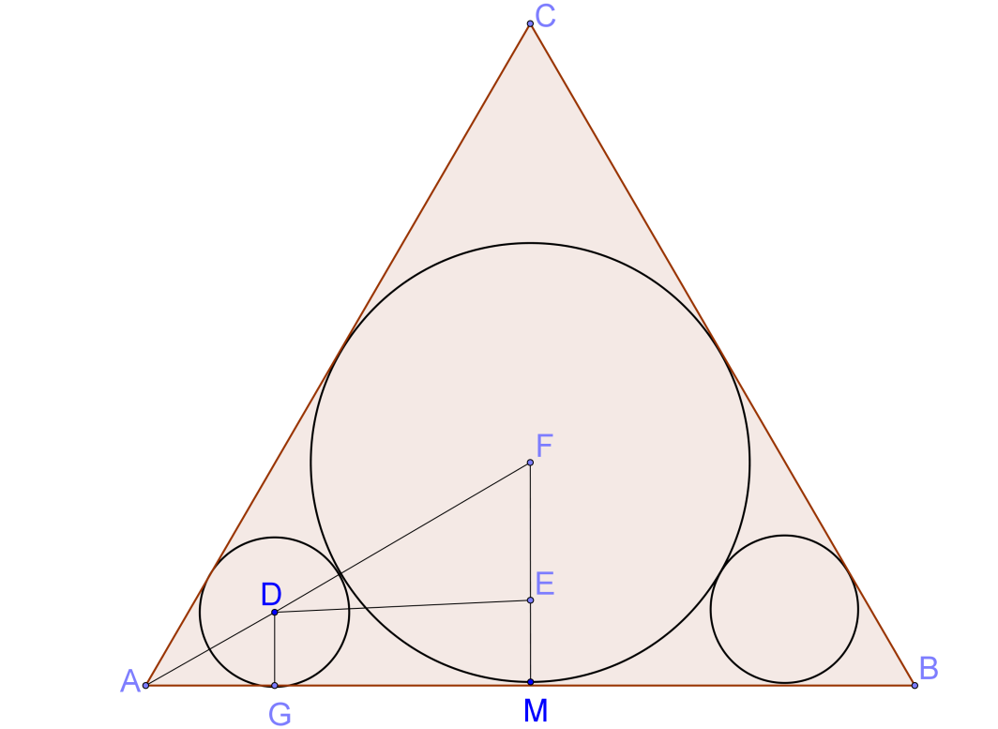

For the bigger circle, $∆DFM$ is a $30°-60°-90°$ triangle and $AM=a$, we have:

$$x=\frac{a}{\sqrt{3}}=\frac{\sqrt{3}a}{3} ….(1)$$

Since $DG = EM = y$, we have $FE=x-y$ and $FD=x+y$

Also, $∆DFE$ is a $30°-60°-90°$ triangle, we have:

$$\frac{x+y}{x-y}=\frac{2}{1}$$

$$y=\frac{x}{3}=\frac{\sqrt{3}a}{9}$$

$$Total area =πx^{2}+2πy^{2}=π{\left(\frac{\sqrt{3}a}{3}\right)}^{2}+2π{\left(\frac{\sqrt{3}a}{9}\right)}^{2}=\frac{11 π a^{2}}{27}$$

$$≈1.2799081181292a^{2}$$

**Comparing Scenario 1 with Scenario 2, the maximum area is $1.2799081181292a^{2}$.**

**Yue Kwok Choy**

**25/10/2015**